One of Tableau’s most powerful features is the ability to create interactive dashboards. These are dashboards where the different worksheets “talk” to each other with filtering and highlight actions.

As an example, reconsider the dashboard we’ve been working on:

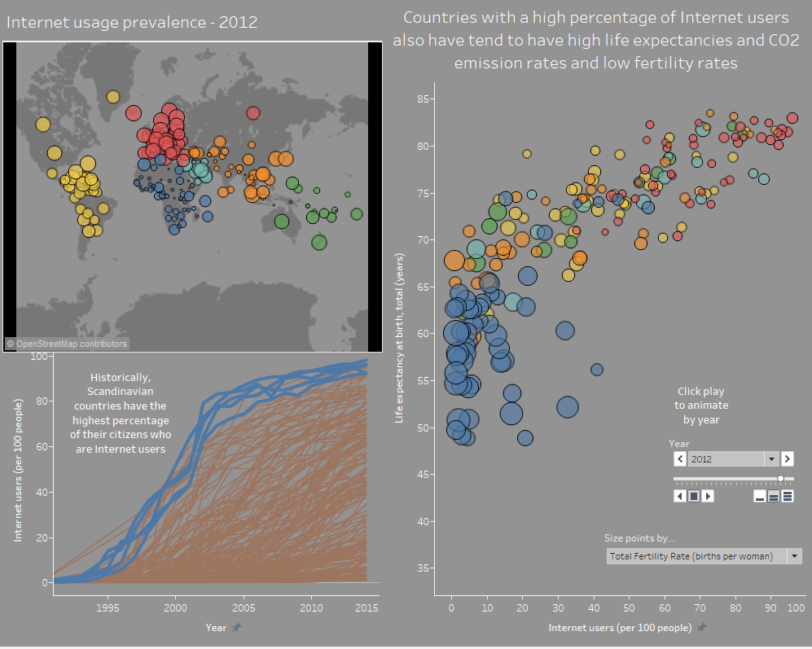

Suppose we want to be able to interact with the map, and have it highlight the relevant countries in the time-trend and scatterplot. We can accomplish this by adding ***dashboard actions***. There are two primary types of actions we will consider in this handout:

* **Highlight actions**: hovering over a data point on one worksheet *highlights* corresponding data points on other worksheets;
* **Filter actions**: hovering over or selecting a data point on one worksheet *filters* corresponding data points on other worksheets.

**Highlight actions**

To add a highlight action to our dashboard:

* Click **Dashboard 🡪 Actions…**
* **Add Action 🡪 Highlight**
* Complete the dialogue box as shown below. Some things to think about:

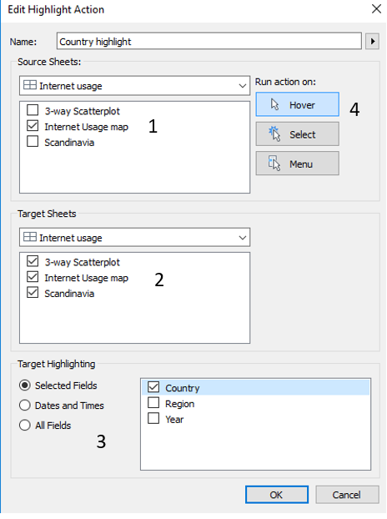

* 1. From which worksheets do you want the interactivity to be sourced? Select these in the “Source Sheets” box
  2. Which worksheets do you want the interactivity to target? Select these in the “Target Sheets” box
  3. **Important: Which fields do you want to control the interactivity?** Control this with the “Target Highlighting.” **Note that the field(s) you select must be present on all selected target and source sheets for the action to work properly!**
  4. Do you want the action to run on hover, or select? Let’s select “Hover” here.

Note the issues with the following; why is this happening?

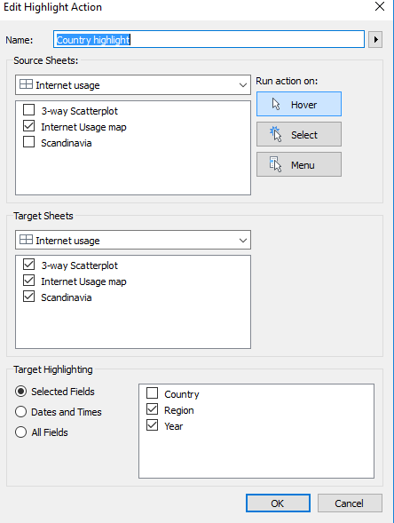

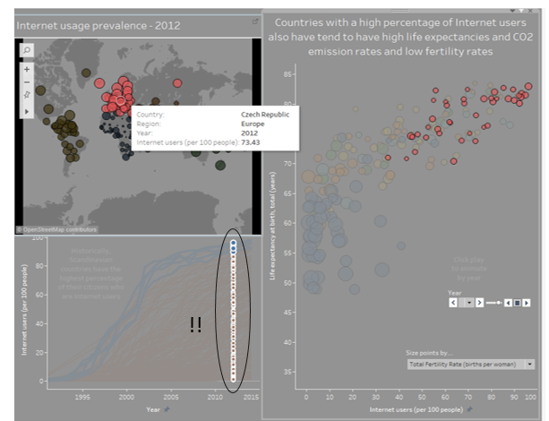

**Filter actions**

Filter actions are set up very similar to highlight actions, but will remove all data that does not satisfy the filter criteria instead of just “graying it out” as with highlight actions. There are, however, a few other options to consider.

* First, remove the highlight action.
* Click **Add Action 🡪 Filter**
* Set up the Source and Target sheets as before, but note a few new options:
  1. What do you want to happen when the filter is removed? Leave or show all? (I have never encountered a situation where the “Exclude all values” option made sense.)
  2. Filtering by a specified field is accomplished by clicking **Add Filter…** at the bottom of the dialogue box, and selecting **Country**.
* Set up the dialogue box as shown below:

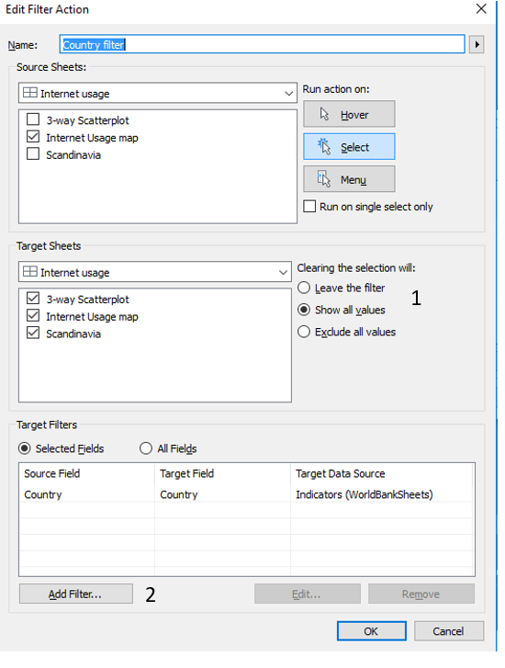

The filter should operate as shown:

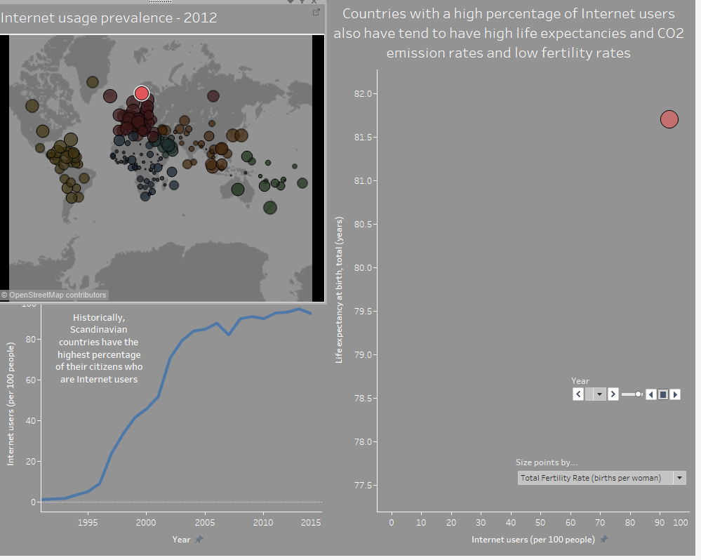

The time trend on the bottom-left is fine, but a lonesome point on the scatterplot is a bit strange! Maybe we should modify.

**Task: create an interactive dashboard that operates to create the view shown below (arrows indicate source/target sheets; you figure out the dashboard actions!)**

